**ECE 315**

**Lab 8: Root locus plots**

**Description:** The root loci of six systems are showed in Figure 1

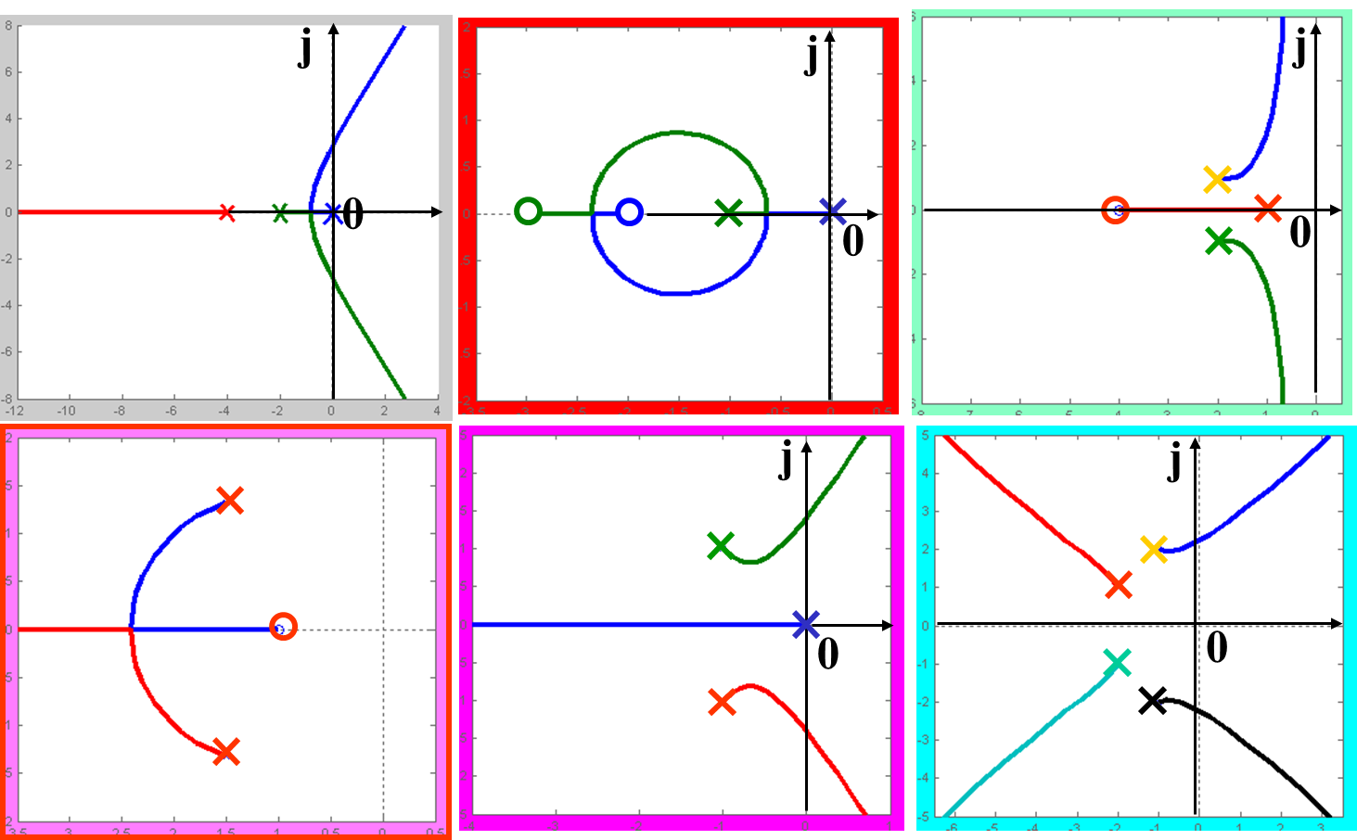

Figure 1

1. Find the transfer function G(s)H(s) for all the six systems
2. With Matlab or OCTAVE, plot the root loci of six systems

Submit requirements:

1. Objective of the lab
2. Matlab .m file
3. Figures
4. Screen shot
5. Conclusions